**ASSIGNMENT-1**

1. Using for loop, write and run a Python program for this algorithm.

Here is an algorithm to print out n! from 0! to 10!

2. Find prime numbers between a given range - start(take start no) , end (take end number)

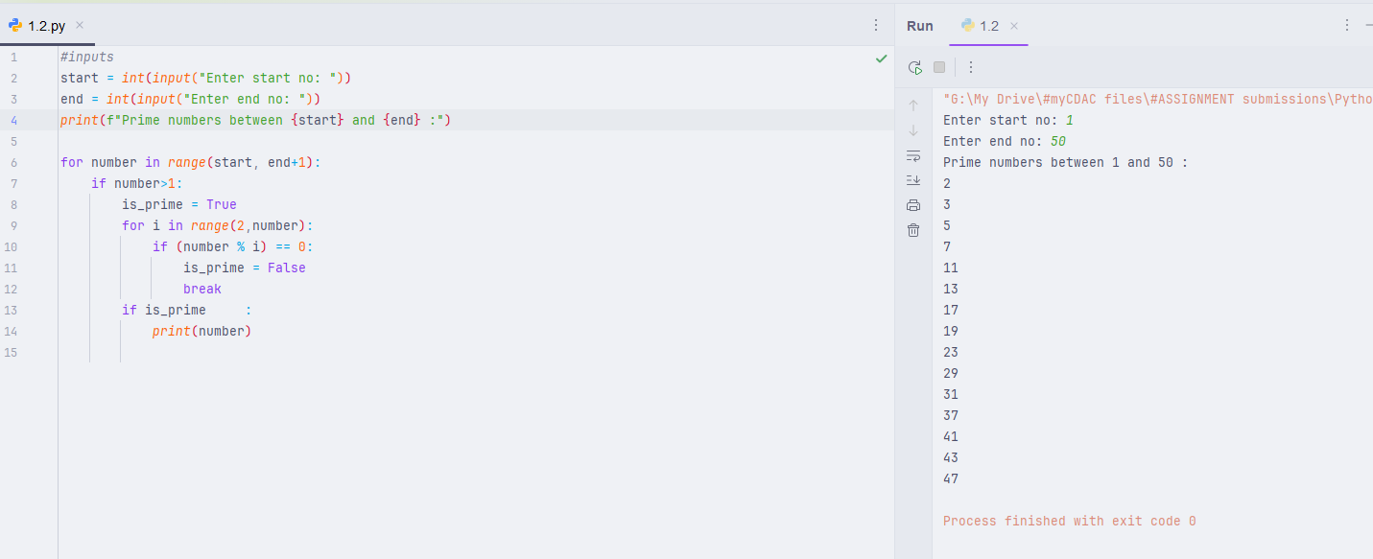

3. Write a python program to swap a 3 digit number

input 321

output 123

4. Count Digits, Even/Odd, Sum

e.g. 23456

output

digits : 5

sum : 20

Even digits : 3

odd digits :2

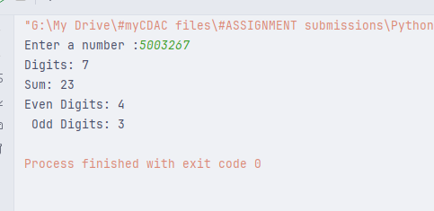

5. Write a program to check if given triangle is valid if 3 sides of the triangle are provided.

Also print the type of triangle

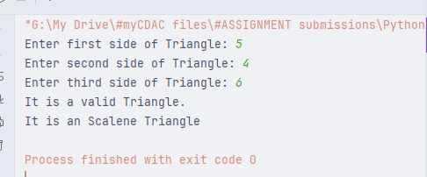

6. Find LCM and GCD for given numbers [take 2 numbers] using loops only

